ECS Task
Complete procedure — ECS HA + ALB + Dynamic Port Mapping
Architecture
Internet
│
▼
┌────────────────────┐
│ Application Load │
│ Balancer :80 │
└─────────┬──────────┘
│
Target Group
│
┌────────────┴────────────┐
│ │
ap-south-1a ap-south-1b
│ │
EC2-1 EC2-2
│ │
┌─────┼─────┐ ┌─────┼─────┐
│ │ │ │ │ │
T1 T2 T3 T4 T5 T6
│ │ │ │ │ │
└─────┴─────┘ └─────┴─────┘

sabair0509/hiring-app:works
The host ports will be dynamically assigned:
EC2-1:32768 → Container:8080
EC2-1:32769 → Container:8080
EC2-1:32770 → Container:8080

PART 1 — Create ECS Cluster
Go to:
ECS → Clusters → Create cluster
Cluster name
ecs-ha-hiring-cluster
Infrastructure
Select:
Fargate and Self-managed instances
Then select:
Create a new Auto Scaling group
Provisioning model
Select:
On-Demand
AMI
Keep:
Amazon Linux 2023
Instance type
For the initial lab, select:
t3.medium
It gives:
2 vCPU
4 GiB RAM
This is more appropriate than t3.small for six application tasks.
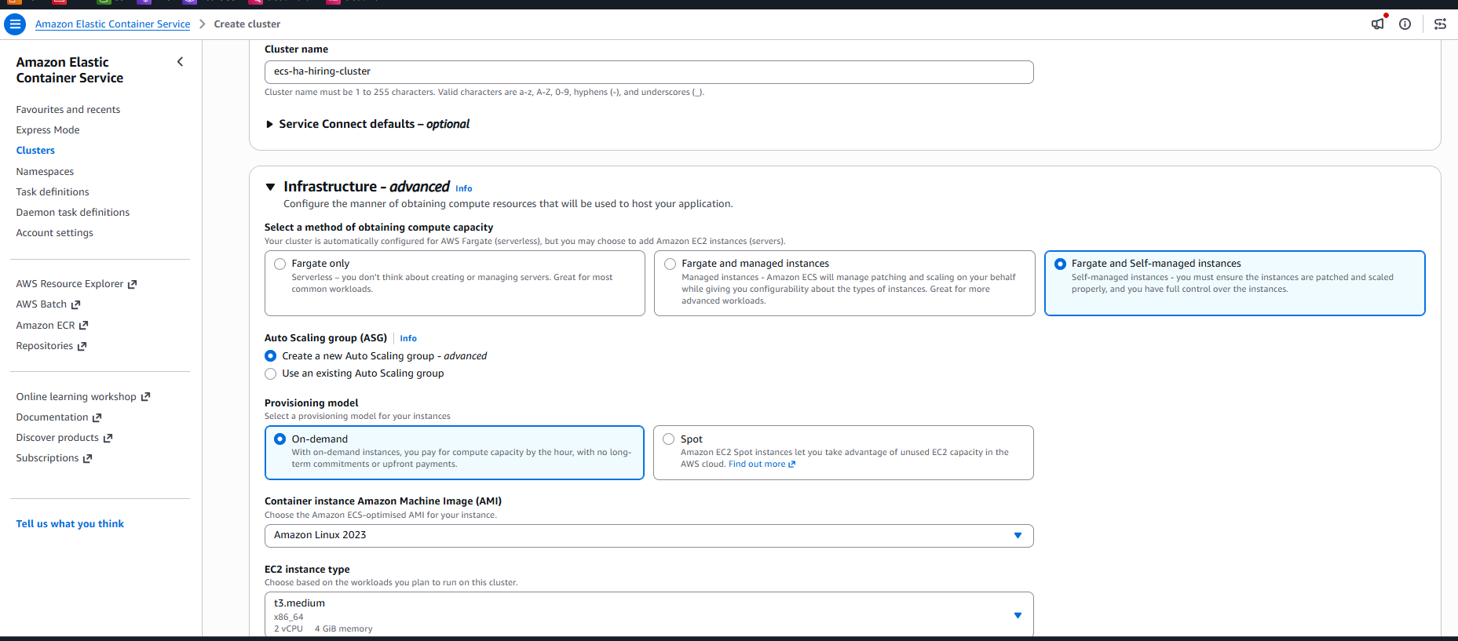

PART 3 — EC2 instance role
Under:
EC2 instance role
Choose:
Create default roles
Let AWS create the ECS instance role.
Do not manually create another random IAM role.

PART 4 — Auto Scaling Group capacity
You'll see:
Desired capacity
Configure:
Minimum: 2
Desired: 2
Maximum: 2
Why 2?
Because we want EC2 capacity in both AZs:
ap-south-1a → EC2
ap-south-1b → EC2
The 6 requirement applies to ECS tasks, not EC2 instances.
Later, if the six tasks don't fit because of CPU/memory requirements, we'll increase EC2 capacity.

PART 5 — SSH
For:
SSH Key pair
You can leave:
None
We don't need SSH for this exercise.

PART 6 — EBS
Keep:
30 GiB
That's enough for this lab.
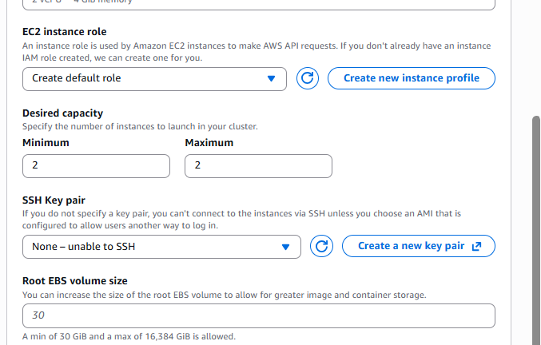

PART 7 — Network
This is important.
Select your existing VPC:
vpc-009cec8ac07410e5d
Select ONLY these two subnets:
Subnet 1
ap-south-1a

subnet-0e7996a2abd1046e6

172.31.32.0/20
Subnet 2
ap-south-1b

subnet-056e9dd1eea5785cf

172.31.0.0/20
Do not select:
ap-south-1c
subnet-0d581b6a6142b2453
Our lab is using two AZs.

PART 8 — Security Group
If the cluster wizard asks you to create/select a security group, create one for the ECS instances.
Name:
ecs-ha-ec2-sg
For now, allow:
SSH 22
only from your IP if you want SSH access.
Don't expose application port 8080 to the whole internet.
Later we'll create a separate ALB security group.
The desired security architecture is:
Internet
│
▼
ALB Security Group
│
▼
EC2 Security Group
│
▼
ECS Tasks

PART 9 — Create the cluster
Review everything:
Cluster:
ecs-ha-hiring-cluster

Infrastructure:
Fargate + Self-managed

ASG:
New

AMI:
Amazon Linux 2023

Instance:
t3.medium

Min:
2

Desired:
2

Max:
2

VPC:
vpc-009cec8ac07410e5d

Subnets:
ap-south-1a
ap-south-1b
Then click:
Create
AWS will create the CloudFormation stack and launch the EC2 capacity.
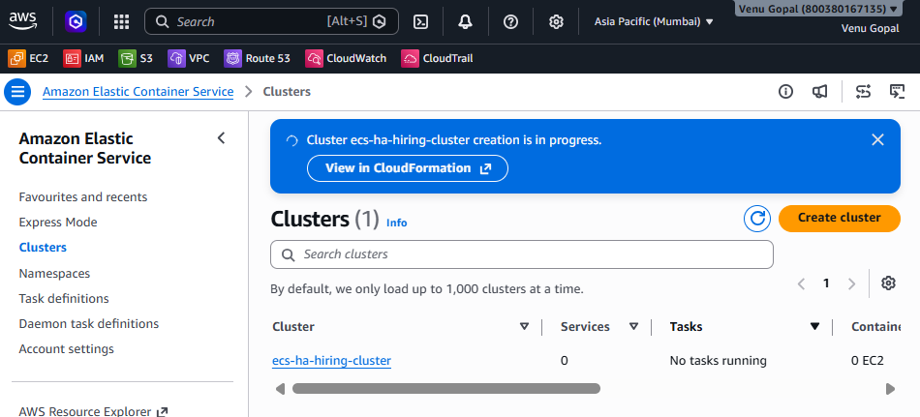

PART 10 — Verify EC2 capacity
After the cluster is created:
ECS → Clusters → ecs-ha-hiring-cluster
Check:
Infrastructure
You should eventually see EC2/container instances registered.
We want approximately:
EC2-1 → ap-south-1a → ACTIVE
EC2-2 → ap-south-1b → ACTIVE
Don't proceed until the instances are registered/active.
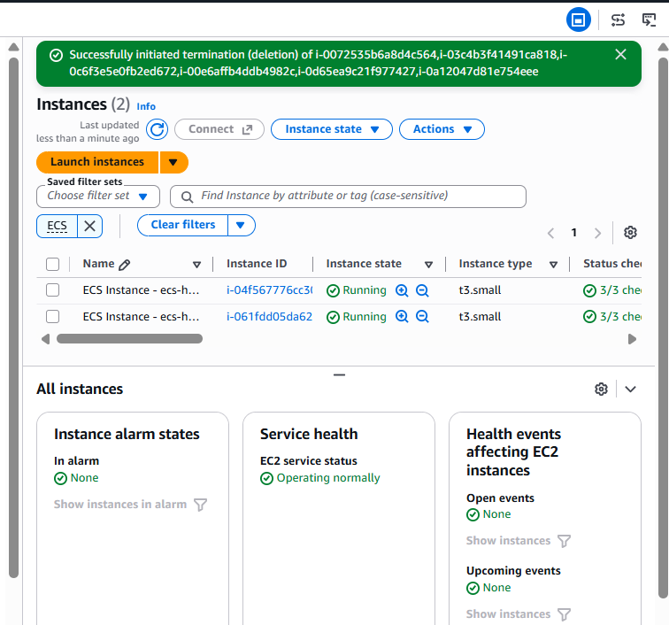

PART 11 — Create Task Definition
Now go to:
ECS → Task definitions → Create new task definition
Select the option for an EC2 task definition / ECS task definition compatible with EC2.
Family
hiring-app-task
Task resources
Start with:
CPU: 0.5 vCPU
Memory: 1 GB
We'll adjust if the image requires more.

PART 12 — Add container
Container name:
hiring-app
Image:
sabair0509/hiring-app:works
Port mapping
This is the most important part of today's exercise.
Set:
Container port: 8080
Host port: 0
Protocol: TCP
⭐ Why Host Port = 0?
Because:
Host port 0
means ECS automatically chooses an available host port.
For example:
Task 1:
EC2:32768 → Container:8080

Task 2:
EC2:32769 → Container:8080

Task 3:
EC2:32770 → Container:8080
This is dynamic port mapping.

PART 13 — Create the task definition
Save/create the task definition.
We should now have:
hiring-app-task
│
└── hiring-app
│
└── sabair0509/hiring-app:works

PART 14 — Create ALB Security Group
Go to:
EC2 → Security Groups → Create security group
Name:
hiring-alb-sg
VPC:
vpc-009cec8ac07410e5d
Inbound:
HTTP
TCP 80
Source: 0.0.0.0/0
This allows users to reach the ALB.
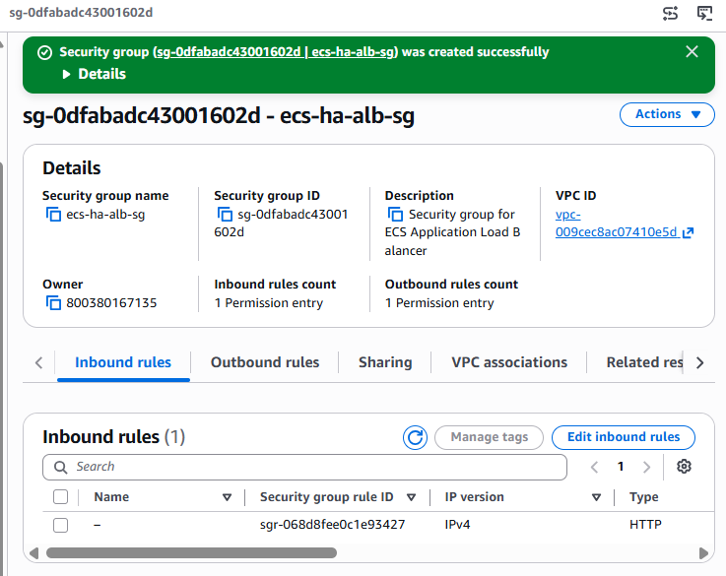

PART 15 — Update ECS EC2 Security Group
The EC2 security group should allow traffic from the ALB security group.
Eventually:
Source:
hiring-alb-sg

Protocol:
TCP

Port:
Dynamic application ports
For an EC2 dynamic-port-mapping lab, the security group needs to permit the dynamically allocated host-port range used by ECS. We will configure this carefully when we create the service/ALB rather than opening everything unnecessarily.
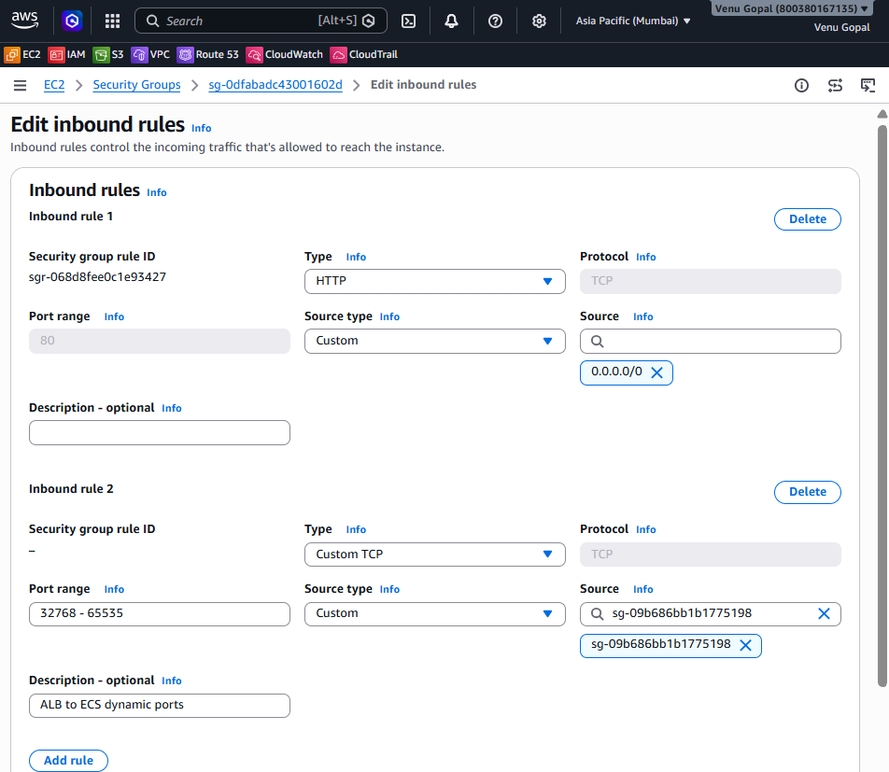

PART 16 — Create Target Group
Go to:
EC2 → Load Balancing → Target Groups
Click:
Create target group
Step 16.1 — Choose target type
Select:
IP addresses ✅
Do not select Instances.

Step 16.2 — Target group details
Enter:
Target group name
hiring-app-tg
Target type
IP addresses
Protocol
HTTP
Port
8080
IP address type
IPv4
VPC
Select:
vpc-009cec8ac07410e5d

Step 16.3 — Health checks
Use:
Health check protocol: HTTP
Health check path: /
Leave the remaining settings at their defaults.

Step 16.4 — Register targets
Do NOT register anything manually.
Leave the target list empty.
ECS will register the task IPs and ports when we create the service.
Click:
Next
Then:
Create target group
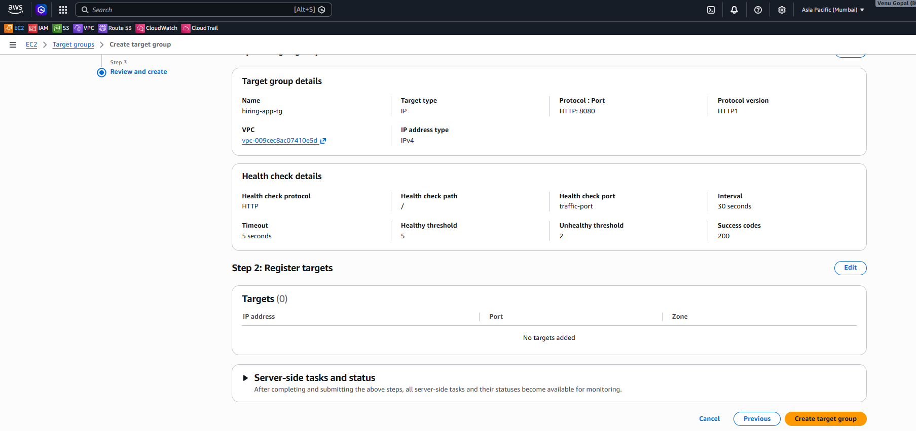

PART 17 — Create Application Load Balancer
Go to:
EC2 → Load Balancers
Click:
Create Load Balancer
Select:
Application Load Balancer
Click Create.

Step 17.1 — Basic configuration
Load balancer name
hiring-app-alb
Scheme
Internet-facing
IP address type
IPv4

Step 17.2 — Network mapping
Select:
VPC:
vpc-009cec8ac07410e5d
Select two Availability Zones/subnets:
ap-south-1a
subnet-0e7996a2abd1046e6
and:
ap-south-1b
subnet-056e9dd1eea5785cf
✅ This gives the ALB multi-AZ availability.

Step 17.3 — Security group
Select:
ecs-ha-alb-sg
This SG has:
HTTP :80
Source: 0.0.0.0/0
That's correct.

Step 17.4 — Listener
Configure:
Protocol: HTTP
Port: 80
Default action:
Forward to:
hiring-app-tg
Create the ALB.
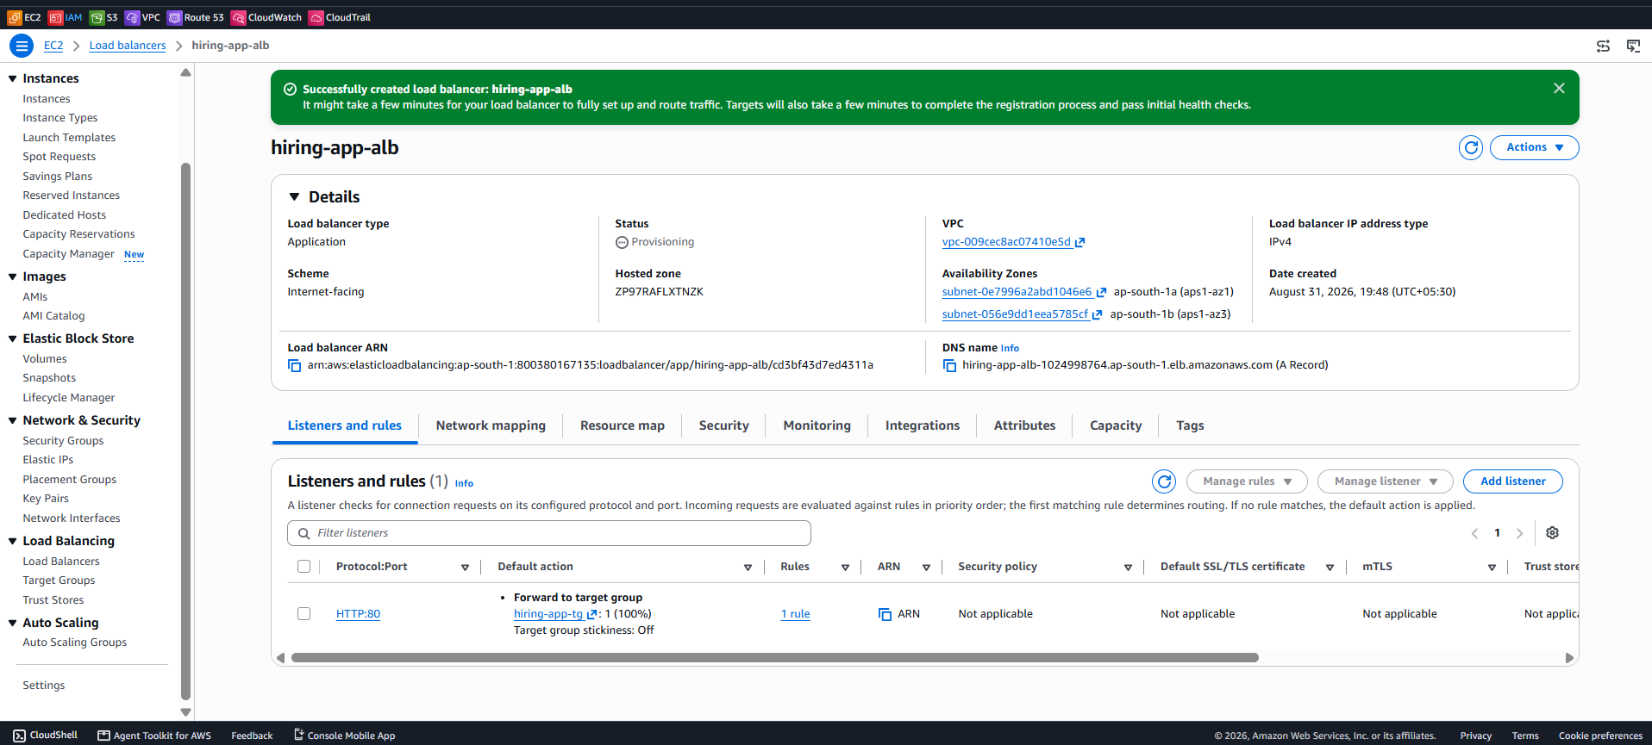

PART 18 — Verify ALB
After creation, wait until:
State: Active
Then open the ALB and note its:
DNS name
It will look similar to:
hiring-app-alb-xxxxxxxx.ap-south-1.elb.amazonaws.com
Don't test it yet. There are no ECS tasks behind it yet.
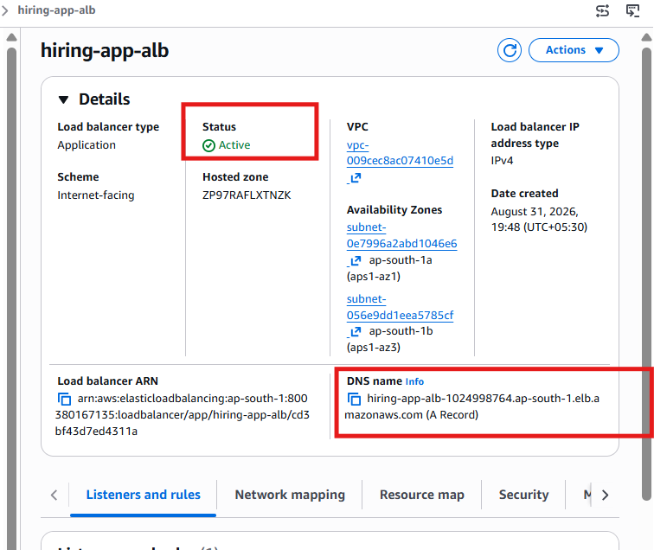

PART 19 — Create ECS Service ⭐
Now go to:
ECS → Clusters → ecs-ha-hiring-cluster
Select:
Services → Create

Step 19.1 — Environment
Select:
Compute options:
EC2
Use your cluster's EC2 capacity.

Step 19.2 — Deployment configuration
Task definition
Select:
Family:
hiring-app-task

Revision:
1
Service name
hiring-app-service

PART 20 — Desired count ⭐⭐⭐
This is one of the most important requirements.
Set:
Desired tasks: 6
So:
Desired = 6
ECS will continuously try to maintain six running tasks.
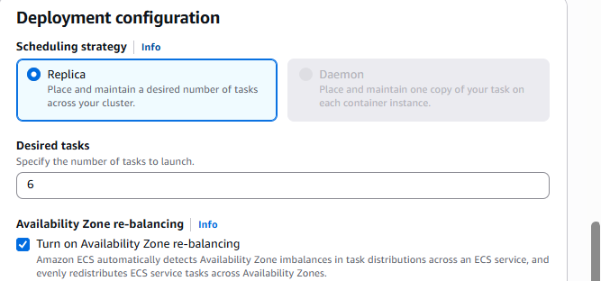

PART 21 — Networking
Select:
VPC
vpc-009cec8ac07410e5d
Subnets
Select:
ap-south-1a
subnet-0e7996a2abd1046e6
and:
ap-south-1b
subnet-056e9dd1eea5785cf
Security group
Select:
ecs-ha-ec2-sg
Do not create another security group here unless the ECS wizard specifically requires a task security group.
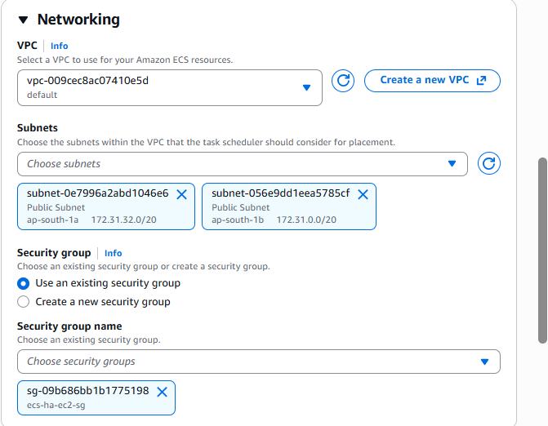

PART 22 — Load Balancing ⭐⭐⭐
Enable:
Use load balancing
Select:
Application Load Balancer
Load balancer
Select:
hiring-app-alb
Listener
Select:
HTTP : 80
Target group
Select:
hiring-app-tg
Container
Select:
hiring-app
Port
Select:
8080
This should correspond to the container port in your task definition.
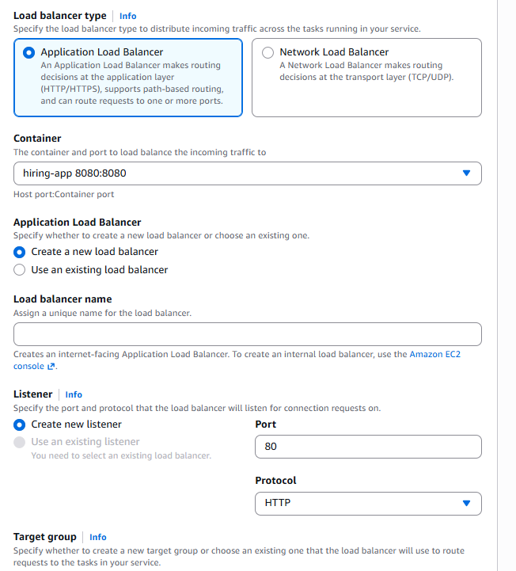

PART 23 — Deployment settings
For this lab, keep the default ECS deployment configuration unless AWS asks you for specific values.
We want ECS to maintain:
6 desired tasks
If a task fails:
6 → 5
ECS launches a replacement:
5 → 6

PART 24 — Create service
Review everything:
Cluster
ecs-ha-hiring-cluster

Service
hiring-app-service

Task definition
hiring-app-task:1

Desired count
6

Subnets
ap-south-1a
ap-south-1b

Load Balancer
hiring-app-alb

Listener
HTTP :80

Target Group
hiring-app-tg

Container
hiring-app : 8080
Then click:
Create
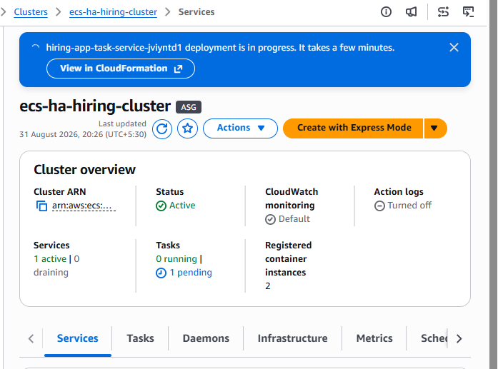

PART 25 — Increase Desired Tasks to 6
Go to:
ECS → Clusters → ecs-ha-hiring-cluster → Services → hiring-app-task-service-jviyntd1
Click:
Update
Find:
Desired tasks
Change:
2
to:
6
Then continue through the update screen and click:
Update service
Then wait
After the update, you should see something like:
Desired: 6
Running: 2 → 3 → 4 → 5 → 6
Pending: may temporarily increase
Deployment: In progress
Eventually we want:
Desired: 6
Running: 6
Pending: 0
Deployment: Success
Because you already have 2 healthy targets, that's a good sign.
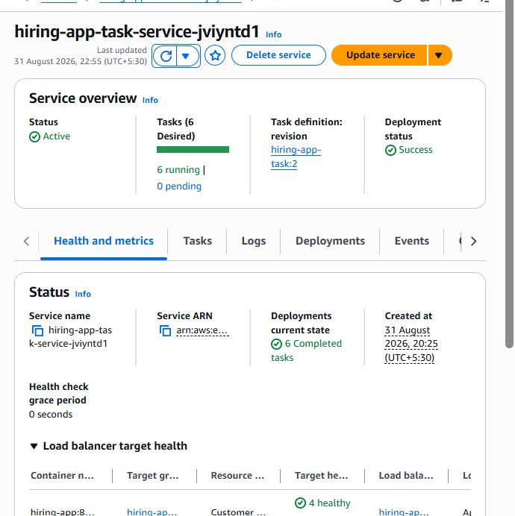

PART 26 — Check Target Group
Do this only after ECS reaches 6 Running / 0 Pending.
Go to:
EC2 → Target Groups → hiring-app-tg → Targets
You should eventually see:
6 targets
and ideally:
Healthy
Healthy
Healthy
Healthy
Healthy
Healthy
Because you're using:
awsvpc
Target type = IP
Container port = 8080
the targets should be the private IP addresses of your ECS tasks.
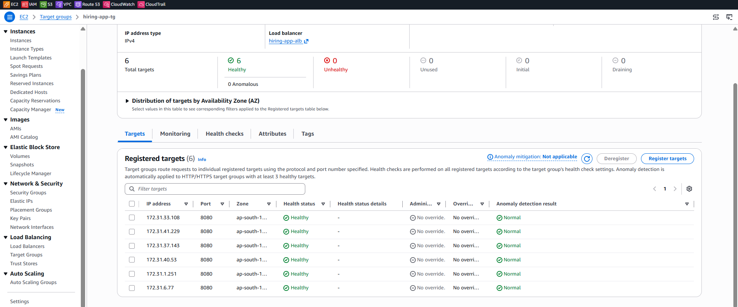

PART 27 — Verify Multi-AZ
Go to:
ECS → Cluster → ecs-ha-hiring-cluster → Services → hiring-app-task-service-jviyntd1 → Tasks
Open the six running tasks and check their Availability Zones.
We want tasks running in both:
ap-south-1a
ap-south-1b
It does not have to be exactly 3 + 3 unless you've configured a placement strategy to enforce that.
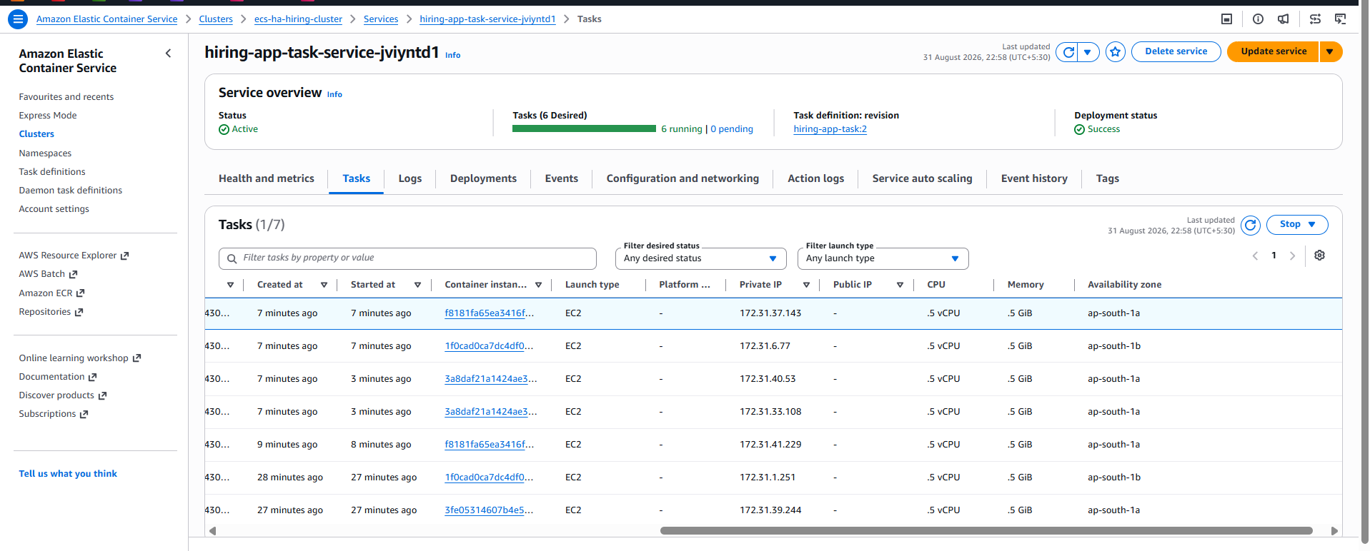

PART 28 — Test Application
Go to:
EC2 → Load Balancers → hiring-app-alb
Copy the:
DNS name
Open it in your browser:
http://hiring-app-alb-1024998764.ap-south-1.elb.amazonaws.com/hiring/
Your hiring application should load.
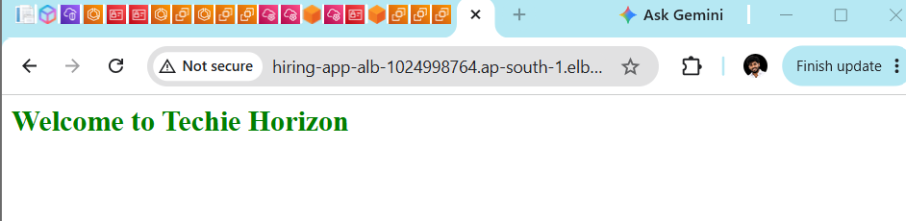

PART 29 — Test Self-Healing ⭐
Only do this after all 6 targets are healthy.
Go to:
ECS → Cluster → Service → Tasks
Select one RUNNING task.
Click:
Stop
You may temporarily see:
Desired: 6
Running: 5
ECS should automatically launch a replacement.
Eventually:
Desired: 6
Running: 6
Pending: 0
That's your ECS self-healing demonstration.
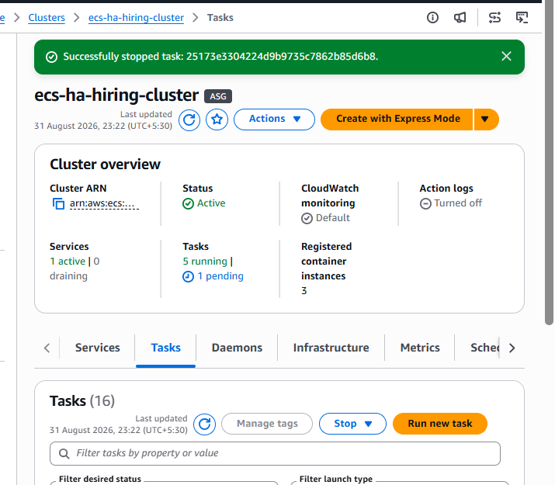

PART 30 — Final Verification
Your final environment should be:
INTERNET
│
│ HTTP :80
▼
┌─────────────────┐
│ hiring-app-alb │
│ ALB │
└────────┬────────┘
│
▼
┌─────────────────┐
│ hiring-app-tg │
│ IP targets │
└────────┬────────┘
│
┌────────┴────────┐
│ │
ap-south-1a ap-south-1b
│ │
ECS Tasks ECS Tasks
T1 T2 T3 T4 T5 T6
│ │
└────────┬────────┘
│
ECS Service
Desired = 6

